**Bapuji Salunkhe Polytechnic, Kolhapur**

**Department Of Computer Science**

**Micro:**

Project Report

**Subject:**

Advance Java

**Title:**

Voting System

**Submitted by:**

|  |  |  |
| --- | --- | --- |
| **ROLL NO.** | **STUDENT NAME** | **Enrollment No.** |
| 203369 | Kanishka Desai | 1800430342 |
| 203371 | Pranjal Haval | 1900430004 |
| 203374 | Adinath Sangaj | 1900430011 |

* **Introduction of micro project:**

The word “vote” means to choose from a list, to select or to determine. The main goal of voting (in a scenario involving the citizens of a given country) is to come up with leaders of the people’s choice. This online voting/polling system seeks to address the above issues. The Online voting system (OVS) also known as e-voting.

This Online Voting system will manage the Voter’s information. The system will incorporate all features of voting system. It provides the tools for maintaining voter’s vote to every party and it count total no. of votes of every party. By online voting system percentage of voting is increases. It decreases the cost and time of voting process. It is very easy to use and It is vary less time consuming. It is very easy to debug.

* **Aim of micro project:**

1. Main aim of this project is to develop a software application to helpful to the voting system.
2. Provision of improved voting services to the voters through fast, timely and convenient voting.
3. It provides voting calculation is very easy & fast.
4. Better look and fill of voting system.

* **Intended course outcome:**

1. Develop program using GUI Framework (AWT and Swing).
2. Handle events of AWT and Swing component.
3. Develop program to handle events in java programming.

* **Purpose:**

Voting is a method for a group, such as a meeting or an electorate, in order to make a collective decision or express an opinion, usually following discussions, debates or election campaigns.

* **Why voting system is imp:**

Voting and democracy is very important in a nation because it provides people an opportunity to voice their opinion and vote for what they believe in, it holds elected officials accountable for their behaviour while in office, and it prevents a minority from dictating the policies of a majority.

* **Why are voting system used? :**

A voting system is a used to register and tabulate votes. The first voting machines were mechanical but it is increasingly more common to use electronic voting machines. ... Voting machines have different levels of usability, security, efficiency and accuracy.

* **literature Review**

TO build our project we took the from following links and books such as:

1: Java book we can refer and name of this book is technical Publication.

2: We can visit the following websites

<http://www.1000projects.org/java-projects.html>

In this website, I am collecting the various information about the advance java programs. Voting programs information available in this website & various techniques about the programming.

<http://www.javatpoint.com/free-java-projects>

In this website, different program available with related to java programming language.

3: In search different website we understood how to create our proposal or project.

* **Proposed methodology**

**Methods of project to improve it:**

* In this project I am going to build an application of voting system.
* We can see the information that what we are stored into it.
* Here are some key features of voting system:
* Using this project, thecandidatename & party name can be seen& then choice your party.
* Result of voting is early provide.

In this project, I create a simple voting system. The purpose of this voting system is to assure the people's right to free and equal elections, as guaranteed by our state Constitution. To that end, the full exercise of that right demand that the people be afforded the means to form political parties, nominate candidates and cast ballots for whomever they choose.

In this project can not possible to any duplicate vote. It can available 8 candidate name you can choice only one candidate name and dabble click to this candidate name. after completion of voting click the “Count Votes” then you can possible to see the result of voting in very less time.

* **Program Code:-**

**package** ajp;

**import** java.awt.*;

**import** java.applet.*;

**import** java.awt.event.*;

**publicclass**Vote**extends** Applet **implements** MouseListener

{

**publicint**count1;

**publicint**count2;

**publicint**count3;

**publicint**count4;

**publicint**count5;

**publicint**count6;

**publicint**count7;

**publicint**count8;

**public**Buttonvote;

Buttonch1;

Buttonch2;

Buttonch3;

Buttonch4;

Buttonch5;

Buttonch6;

Buttonch7;

Buttonch8;

TextField ncp;

TextField bjp;

TextField inc;

TextField ss;

TextField wba;

TextField manse;

TextField apk;

TextField aap;

**publicvoid** init()

{

count1 =0;

count2 =0;

count3 =0;

count4 =0;

count5 =0;

count6 =0;

count7 =0;

count8 =0;

**this**.setBackground(Color.***gray***);

setLayout(**new** BorderLayout());

Panel p1 =**new** Panel();

p1.setBackground(Color.***lightGray***);

p1.setLayout(**new** GridLayout(8,200,100,45));

ch1 =**new**Button("Bhartiy Janata Party"+" "+"Candidate Name: Narendra Modi");

Font f1 = **new** Font("Helvetica",Font.***BOLD***,20);

ch1.setFont(f1);

ch1.setBackground(Color.***white***);

ch2 =**new**Button(" National Congress party"+""+"Candidate Name: Rahul Gandi");

ch2.setFont(f1);

ch2.setBackground(Color.***white***);

ch3 =**new**Button("Indian National Congress"+" "+"Candidate Name: Sharad Pavar");

ch3.setFont(f1);

ch3.setBackground(Color.***white***);

ch4 =**new**Button("ShivSena"+""+"Candidate Name: Uddhav Thakare");

ch4.setFont(f1);

ch4.setBackground(Color.***white***);

ch5 =**new**Button("Wanchit Bahujan Aaghadi"+"Candidate Name: GopichandPadalkar");

ch5.setFont(f1);

ch5.setBackground(Color.***white***);

ch6 =**new**Button("Maharastra Navbirman Sena"+"Candidate Name: Raj Thakare");

ch6.setFont(f1);

ch6.setBackground(Color.***white***);

ch7 =**new**Button("Apaksha"+""+"Candidate Name: Prakash Shendage");

ch7.setFont(f1);

ch7.setBackground(Color.***white***);

ch8=**new**Button("Aam Aadmi party"+" "+"Candidate Name: Mayawati");

ch8.setFont(f1);

ch8.setBackground(Color.***white***);

ncp = **new** TextField("NCP: " + String.*valueOf*(count1));

ncp.setEditable(**false**);

ncp.setFont(f1);

bjp = **new** TextField("BJP: " + String.*valueOf*(count2));

bjp.setEditable(**false**);

bjp.setFont(f1);

inc = **new** TextField("INC: " + String.*valueOf*(count3));

inc.setEditable(**false**);

inc.setFont(f1);

ss = **new** TextField("SS: " + String.*valueOf*(count4));

ss.setEditable(**false**);

ss.setFont(f1);

manse = **new** TextField("MANSE: " + String.*valueOf*(count5));

manse.setEditable(**false**);

manse.setFont(f1);

apk = **new** TextField("APK: " + String.*valueOf*(count6));

apk.setEditable(**false**);

apk.setFont(f1);

aap= **new** TextField("AAP: " + String.*valueOf*(count7));

aap.setEditable(**false**);

aap.setFont(f1);

wba = **new** TextField("WBA: " + String.*valueOf*(count8));

wba.setEditable(**false**);

wba.setFont(f1);

p1.add(ch1);

ch1.addMouseListener (**this**);

p1.add(bjp);

p1.add(ch2);

ch2.addMouseListener (**this**);

p1.add(ncp);

p1.add(ch3);

ch3.addMouseListener (**this**);

p1.add(inc);

p1.add(ch4);

ch4.addMouseListener (**this**);

p1.add(ss);

p1.add(ch5);

ch5.addMouseListener (**this**);

p1.add(wba);

p1.add(ch6);

ch6.addMouseListener (**this**);

p1.add(manse);

p1.add(ch7);

ch7.addMouseListener (**this**);

p1.add(apk);

p1.add(ch8);

ch8.addMouseListener (**this**);

p1.add(aap);

add("North",p1);

Label l =**new** Label("Click to choose the Party");

Font f = **new** Font("Helvetica",Font.***BOLD***,120);

l.setFont(f);

add("Center",l);

SingleAction sa = **new** SingleAction();

vote =**new**Button("Count Votes");

Font ff = **new** Font("Helvetica",Font.***BOLD***,30);

vote.setFont(ff);

vote.addActionListener(sa);

add("East",vote);

vote.setBackground(Color.***orange***);

}

**publicvoid** mouseClicked(MouseEvent arg0)

{

**if**(arg0.getSource()==ch1)

{

count2=count2+1;

}

**if**(arg0.getSource()==ch2)

{

count1=count1+1;

}

**if**(arg0.getSource()==ch3)

{

count4=count4+1;

}

**if**(arg0.getSource()==ch4)

{

count7=count7+1;

}

**if**(arg0.getSource()==ch5)

{

count5=count5+1;

}

**if**(arg0.getSource()==ch6)

{

count3=count3+1;

}

**if**(arg0.getSource()==ch7)

{

count8=count8+1;

}

**if**(arg0.getSource()==ch8)

{

count6=count6+1;

}

}

@Override

**publicvoid** mouseEntered(MouseEvent arg0) {}

@Override

**publicvoid** mouseExited(MouseEvent arg0) {}

@Override

**publicvoid** mousePressed(MouseEvent arg0) {}

@Override

**publicvoid** mouseReleased(MouseEvent arg0) {}

**class** SingleAction **implements** ActionListener

{

**publicvoid** actionPerformed(ActionEvent e)

{

ncp.setText("NCP: " + String.*valueOf*(count1));

bjp.setText("BJP: " + String.*valueOf*(count2));

manse.setText("MANSE: " + String.*valueOf*(count3));

wba.setText("WBA: " + String.*valueOf*(count5));

inc.setText("INC: " + String.*valueOf*(count4));

aap.setText("AAP: " + String.*valueOf*(count6));

ss.setText("SS: " + String.*valueOf*(count7));

apk.setText("APK: " + String.*valueOf*(count8));

}

}

}

**Output:-**

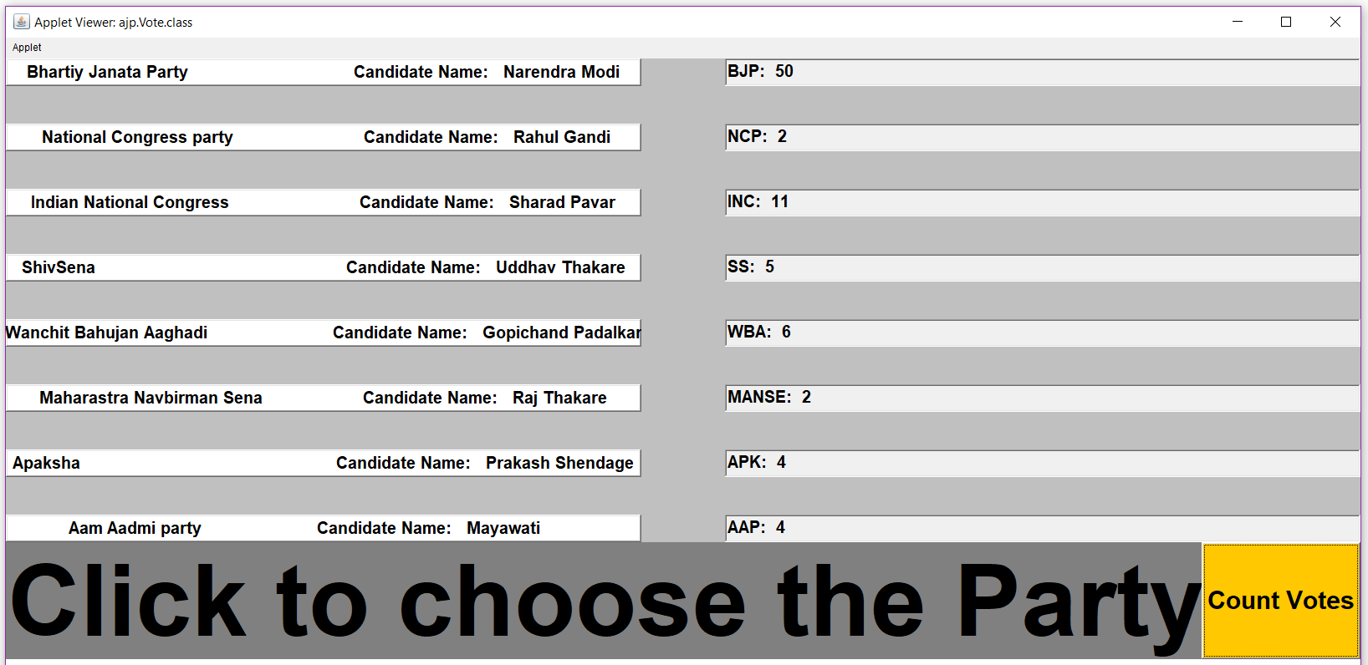

* **Resources Used:**

|  |  |  |  |  |
| --- | --- | --- | --- | --- |
| **Sr.no** | **Name of Resource/material** | **Specifications** | **Qty.** | **Remarks** |
| 1 | **Computer system** | HP Intel Core i3 7th Gen,  4GB Ram, 1TB HDD | 1 |  |
| 2 | **Software Used** | Google Chrome, MS world 2016, Eclipse Neon 3, Notepad, command prompt | 1 |  |
| 3 | **Computer** | IP Address | 1 |  |
| 4 | **Other Resources** | Printer | 1 |  |

**Skills Development :-**

1. We were able to develop the awt components.
2. We also learn to use swing components.

**Application Of This Micro Project :-**

1.Use to open the files using this program.